10/4/2026
Brandon Pepna

WESTERN PACIFIC UNIVERSITYCMN224 / CMP224 Software Engineering — Week 10
Task 4 Assembly Checklist

WESTERN PACIFIC UNIVERSITY
CMN224 / CMP224 Software Engineering — Week 10
Task 4 Assembly Checklist
Design & Modelling Deliverable — 15%, due Week 11 · this is assembly, not new work
Item | Details
Task 4 | Design & Modelling Deliverable — 15%, due Week 11
ULOs | ULO2 and ULO1
What it needs | A use-case model, class diagram, state and activity diagrams, an outline architecture, and at least one applied design pattern
Where it comes from | Lab 4 (Week 5) and Lab 6 (Week 9). If you did both, most of Task 4 already exists.
Read this first. Task 4 is not a new piece of work. It is your Week 5 architecture plus your Week 9 diagrams, made consistent with each other and with your SRS, plus one design pattern. Students who treat it as a fresh start waste a week they do not have — Quiz 3 is in the same week.

Component | Where it came from | Have I got it?
Outline architecture | Lab 4, Week 5 — package diagram | 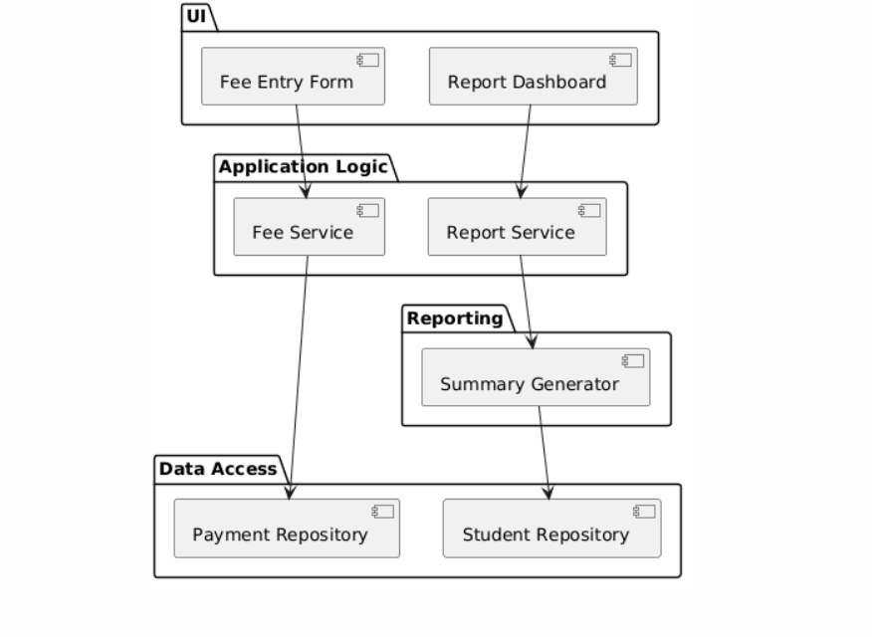
Deployment view | Lab 4, Week 5 — deployment diagram | 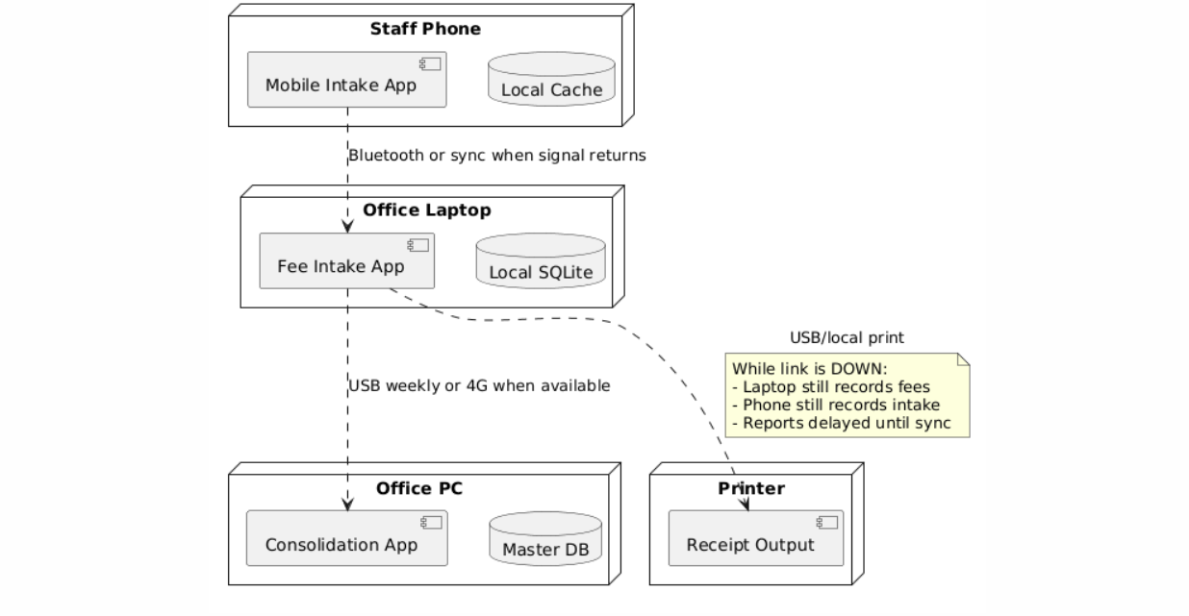
Use case model | Lab 6, Week 9 | 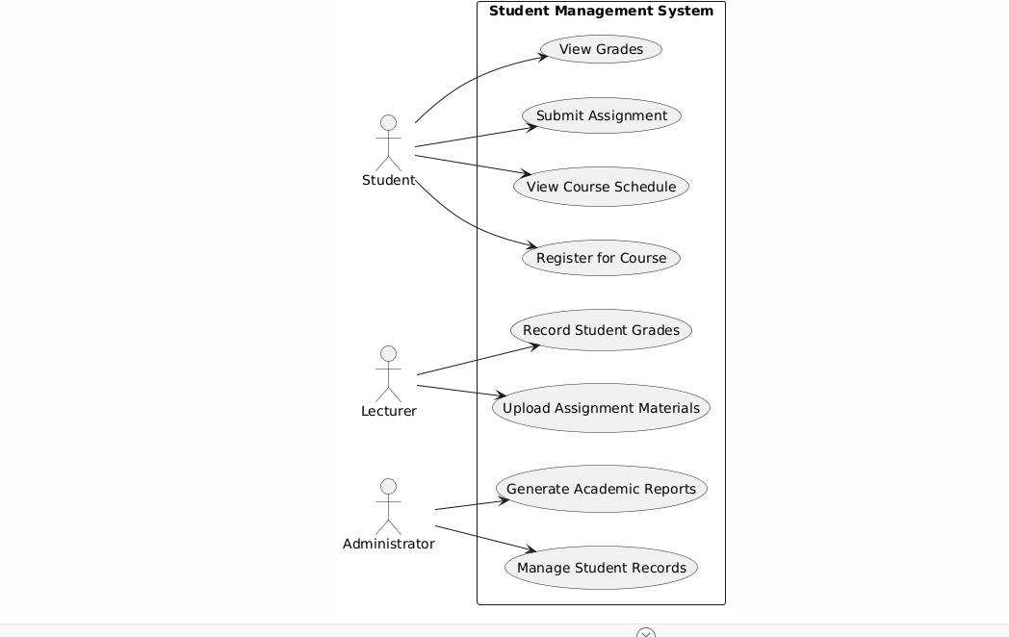
Class diagram | Lab 6, Week 9 | 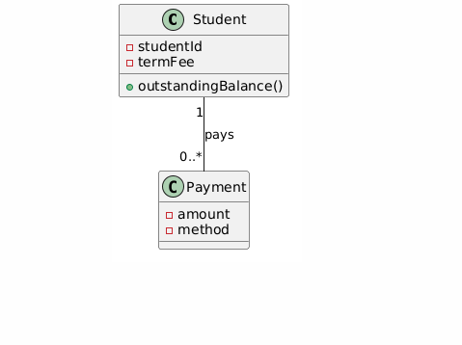
State diagram | Lab 6, Week 9 | 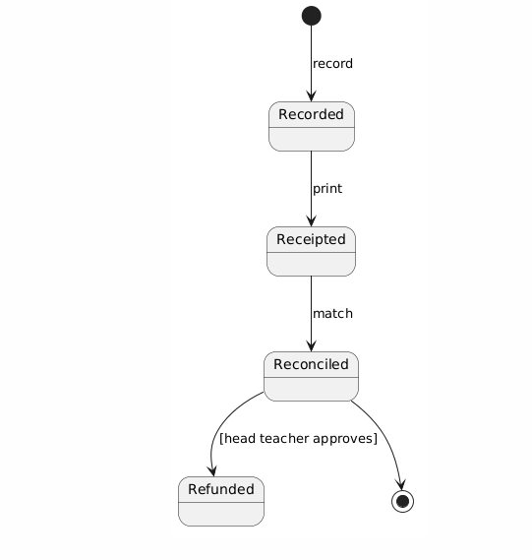
Activity diagram | Lab 6, Week 9 | 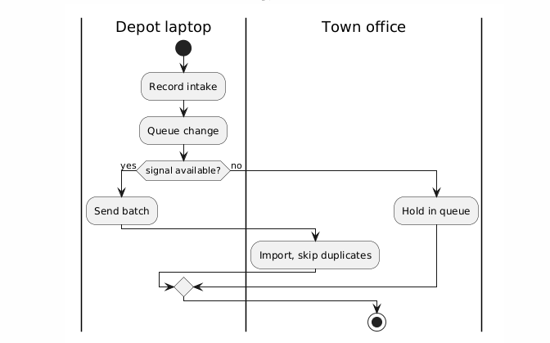
Design pattern applied | Weeks 13–14 teach patterns — see the note below | 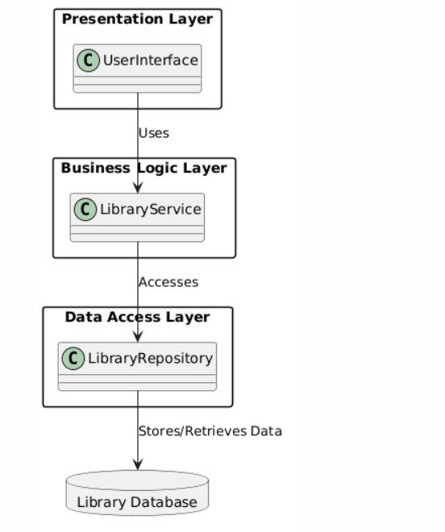
Diagram Explanations
Deployment Diagram Description
This deployment diagram shows how the fee intake system is distributed across different devices, including the Staff Phone, Office Laptop, Office PC, and Printer. The diagram illustrates how data is collected on mobile devices, synchronised to the office laptop, consolidated on the office PC, and printed when required. A key design decision recorded in this diagram is the use of local storage (Local Cache and Local SQLite) on mobile and laptop devices, allowing fee intake activities to continue even when network connectivity is unavailable.
Outline architecture Diagram Description

This package diagram presents the overall software architecture of the Fee Intake System. It shows the major packages, including the User Interface layer (Fee Entry Form and Report Dashboard), the Application Logic layer (Fee Service and Report Service), the Reporting layer (Summary Generator), and the Data Access layer (Payment Repository and Student Repository). A significant design decision represented in this diagram is the separation of business logic from data access through dedicated service and repository components, which improves scalability, maintainability, and ease of testing.
Use Case Diagram Description
This use case diagram shows the interactions between the different users of the Student Management System and the services available to them. Students can view grades, submit assignments, view course schedules, and register for courses, while lecturers manage grades and learning materials, and administrators manage student records and academic reports. A key design decision recorded in this diagram is the separation of system functions based on user roles, ensuring that each actor only has access to the features required for their responsibilities.
Class Diagram Description
This class diagram shows the static structure of the student fee management system by identifying the main classes, their attributes, operations, and relationships. The diagram illustrates that a student can make multiple Payments, while each Payment is associated with a single Student. A key design decision recorded in this diagram is the use of a one-to-many relationship between Student and Payment, allowing the system to track multiple fee payments made by a student over time while maintaining accurate outstanding balance calculations.
State Diagram Description
This state diagram shows the lifecycle of a fee payment record as it moves through different states within the system. The process begins when a payment is recorded, then progresses to receipted and reconciled states before either being completed or refunded. A key design decision recorded in this diagram is the use of a business rule requiring approval before a reconciled payment can be refunded, ensuring that refunds are properly authorised and controlled.

Activity Diagram Description
This activity diagram shows the workflow for processing student fee intake records between the depot laptop and the town office. The process begins when fee information is recorded and queued on the depot laptop. If a network signal is available, the data is sent to the town office and imported into the system; otherwise, the records are held in a queue until connectivity is restored. A key design decision recorded in this diagram is the implementation of an offline processing mechanism, allowing fee transactions to continue being recorded even when there is no network connection, with synchronisation occurring once communication is available.
Design Pattern Applied (Layered Architecture Pattern)
This diagram shows the Layered Architecture Pattern used in the system, which is organised into the Presentation Layer, Business Logic Layer, Data Access Layer, and Database Layer. The diagram illustrates how requests flow from the user interface through business services and repositories before reaching the database. A key design decision recorded in this diagram is the separation of responsibilities into distinct layers, ensuring that the user interface cannot access the database directly. This improves maintainability, scalability, and makes the system easier to test and modify.

To successfully complete Task 4 using the Layered Structure Architecture for the Kina Ridge Primary School scenario, you need to clearly separate your system's responsibilities into distinct layers.
Since this pattern focuses on separation of concerns, you must explicitly state where it is applied in your project and what benefits (what it buys you) it brings to the school's software system.
Here is a breakdown of how to structure your implementation and answer the task requirements.

1. Where it is Applied (The Three-Layer Architecture)
For the Kina Ridge Primary School system (which likely manages student enrollment, grades, classes, or teacher assignments), you should organize your code into three distinct layers:
- Presentation Layer (UI):
  - Where: The user interface forms, web pages, or console menus that school staff (e.g., administrative officers, teachers) interact with.
  - Example: A RegistrationForm where an admin types in a new student's details or a ReportCardView for teachers.
- Business Logic Layer (BLL / Domain):
  - Where: The core rules and calculations governing the school. The Presentation Layer passes data here; it never talks directly to the database.
  - Example: A StudentManager or EnrollmentService class that enforces rules like "A class cannot exceed 30 students" or "A student must be at least 5 years old to enroll."

- Data Access Layer (DAL):
  - Where: The code responsible for saving and retrieving school data from your storage system (database, JSON files, or memory lists).
  - Example: A StudentDataGateway or DatabaseHelper class that runs SQL queries or reads/writes text files to fetch student records.

2. What It Buys You (The Explanation)
The documentation, explain that choosing this pattern provides three major engineering benefits to Kina Ridge Primary School:
- Maintainability & Separation of Concerns: If the school changes its enrollment rules (e.g., maximum class size drops to 25), you only modify the Business Logic Layer. The UI and Data layers remain completely untouched.
- Swappable Storage (Flexibility): If the school currently stores data in a simple text file but decides to upgrade to a SQL Database next semester, you only have to rewrite the Data Access Layer. The business rules and user interface will function exactly the same way.
- Independent Testing: You can test the school's grading logic or registration rules independently without needing to open up a real database or click through a user interface.

3. Quick Checklist for Your Brief
To ensure you hit the exact expectations of the Task 4 brief, make sure your report explicitly states:
- Identified Pattern: Layered Structure Architecture.
- Location: The pattern is implemented in the Week 5 package diagram consisting of the Presentation Layer, Business Logic Layer, Data Access Layer and Database Layer.
- Justification: The Layered Architecture pattern separates responsibilities between layers, improving maintainability, scalability, and testing. It also allows changes in the user interface without affecting the database layer.

Consistency checks — this is where the marks are
Task 4 is marked on the correctness and consistency of your models with the requirements — not on neatness. Run these checks before you submit.

# | Check | Fixed?
1 | Every use case traces to a user requirement in my SRS | YES. The use cases correspond to requirements identified in the SRS, including recording payments, generating receipts, managing student records, and producing reports. These requirements are documented in FR-01 through FR-05.
2 | Every class attribute appears somewhere in my requirements | YES. The class attributes such as studentId, termFee, amount, and method are derived from the SRS requirements relating to student records, fee tracking, payment recording, and receipt generation.
3 | At least one multiplicity encodes a real business rule | YES. The class diagram shows a Student has 0..* Payments, while each Payment belongs to 1 Student. This represents the business rule that students may make multiple instalment payments toward their fees.
4 | At least one state transition carries a guard from a business rule | YES. The state diagram includes the guard condition [head teacher approves] before a refund can occur. This reflects the business rule that refunds require approval.
5 | My activity diagram has a branch for the offline / no-power case | YES. The activity diagram contains the decision node"signal available?". If no signal exists, transactions are placed in a queue and processed later when connectivity returns. This supports the offline-first requirement.
6 | The swimlanes match the devices in my deployment diagram | YES. The activity diagram uses the swimlanes Depot Laptop and Town Office, which correspond to devices and locations identified in the deployment architecture.
7 | Every class is placed on some machine in the deployment view | YES. User interface functions execute on school laptops, business services run within the application layer, and repositories/databases are deployed on local school devices and the central agency infrastructure.
8 | No package has an upward dependency arrow | YES. The architecture follows a layered structure: Presentation Layer → Business Logic Layer → Data Access Layer → Database. Dependencies flow only downward.
9 | One scenario traces cleanly through all five views | YES. The scenario "Record Student Fee Payment" appears in the use case model, class diagram, state diagram, activity diagram, architecture model, and deployment view, demonstrating consistency across all models.
10 | The design pattern is named, located and justified | YES. The Layered Architecture Pattern is identified in the package diagram and architecture design. It separates presentation, business logic, and data access responsibilities, improving maintainability and scalability.

Design Pattern Justification
Pattern Name: Layered Architecture Pattern
Location: Architecture/Package Diagram
Justification:
The Layered Architecture Pattern separates the system into Presentation, Business Logic, Data Access, and Database layers. User interface components communicate with service classes, which access repositories for data storage and retrieval. This separation improves maintainability, testability, scalability, and simplifies future system enhancements. The pattern also supports the offline-first approach required by the school fee system.
AI Use: I used AI support because it helps me take complex or lengthy information and turn it into shorter, clearer, and more understandable points. Instead of manually condensing large amounts of detail, AI can quickly highlight the most important ideas, organize them logically, and present them in a way that is easy to grasp. This makes studying, preparing reports, or drafting assignments more efficient, while ensuring that the content remains accurate and focused on the key requirements.

